CS 152 Project

# Details :-

Kripali Bhatodra

# Description of Project :-

The idea of our project is to make the well known game

“Ping-pong” in Drracket software .

In this game there will be two paddle on left and right side of screen and there will be a ball jumping around the screen in such a away that you had to avoid its collision from left and right wall by moving the paddle and hitting the ball with the paddle .

Player who failed to hit the ball will lose the game .

# Overall Idea Of Design Of Program :-

Our game will have two Modes of playing, single player mode and multiplayer mode.

The program will call a big-bang function which will prompt a screen asking to choose the mode of playing.

Depending on our choice, it will call another big-bang function, from where our playing game screen will pop-up.

When first our program is executed, instruction window will pop-up as shown in the picture.

After that, in response to our input, playing game screen will pop-up accordingly. This screen is also shown below. The state of whole game is contented in a vector which have position of ball, velocity of ball and the position of paddles. When the game starts and respective programs are called out each time this vector is getting updated . whenever the ball is colliding the paddles it’s velocity is changing according to the paddle positions i.e ball will gain more velocity when it is hitted at the corner.

We are also checking the ball so that it doesn’t go beyond any screen , we are simply doing it by changing ball’s direction properly and if the ball goes to any Certain limit the game- over text will come ,which means you were not abled to hit the ball.

# Sample Input-Output :-

When instruction window pop-up it will demand two keys , “1” or

“2” either for single player mode or for multiplayer mode.

For single player Mode the inputs will be “up” and “down” keys of keyboard and the ouput will be the movement of left paddle up and down respectively.

For multiplayer Mode the inputs will be “w” , “s” , “up” and “down” keys on which the

Output will be up and down movement of left paddle in case of “w” and “s” keys and the same movement of right paddle in case of “up” and “down” keys.

There is an option of Pause implemented in game which came as output when the key “P” is pressed as input.

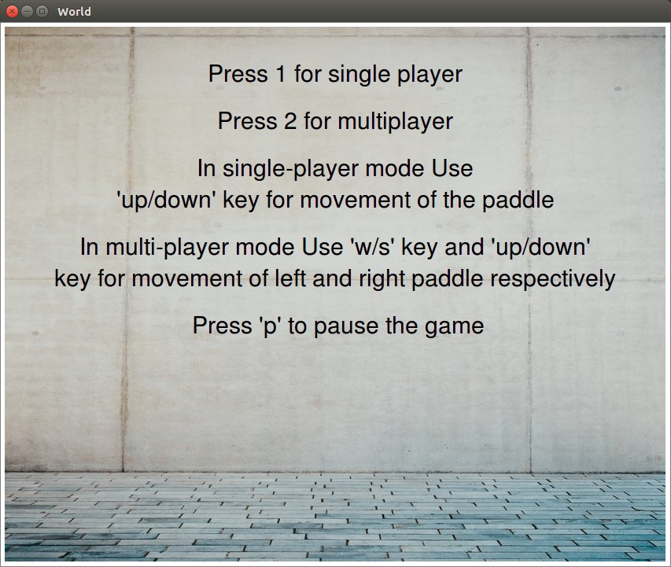

# Limitations and Bugs :-

In our program, once ball goes out of bounds, then the game will be closed. Now, if you want to play again the game, you will have to close the window and again executing the program.

# Point of Interest :-

In single player mode, the right paddle moves on its own in response to the ball position which can be thought as of elementary artificial intelligence.

